PowerShell Tech Odyssey

Public sharing cleanup: Original branding, classroom submission instructions, local usernames, computer names, and visible sensitive details were removed or redacted. Screenshots are self-captured lab evidence and were sanitized for public portfolio use.

Project Overview
This project demonstrates practical PowerShell usage across five hands-on modules. The goal is to show the workflow clearly enough for a recruiter, hiring manager, or technical reviewer to understand what was built, what tools were used, and what evidence supports the work.
Module | Focus Area | Main Skill Demonstrated | Evidence Included
1 | XML Artifact | XML parsing, string transformation, report generation | Decryption report screenshot
2 | Database Chronicles | SQL Server connection, table creation, insert/query workflow | SQL Server install and query output screenshots
3 | Web Wizardry | Selenium automation with PowerShell | Automation execution screenshot
4 | DSC Chronicles | PowerShell DSC configuration planning | DSC configuration screenshot
5 | Grand Convergence | Combining XML, database, web, and configuration tasks | Repository structure and publishing checklist

Recommended GitHub Repository Structure
Use a clean repository structure so reviewers can quickly find code, screenshots, and documentation. Keep generated files, temporary logs, and local machine outputs out of the public repo.
PowerShell-Tech-Odyssey/
├── README.md
├── .gitignore
├── scripts/
│ ├── chapter1-xml-scroll.ps1
│ ├── chapter2-sql-treasure.ps1
│ ├── chapter3-web-automation.ps1
│ ├── chapter4-dsc-config.ps1
│ └── chapter5-integration.ps1
├── assets/
│ └── screenshots/
└── docs/
└── PowerShell_Tech_Odyssey_GitHub_Clean.docx

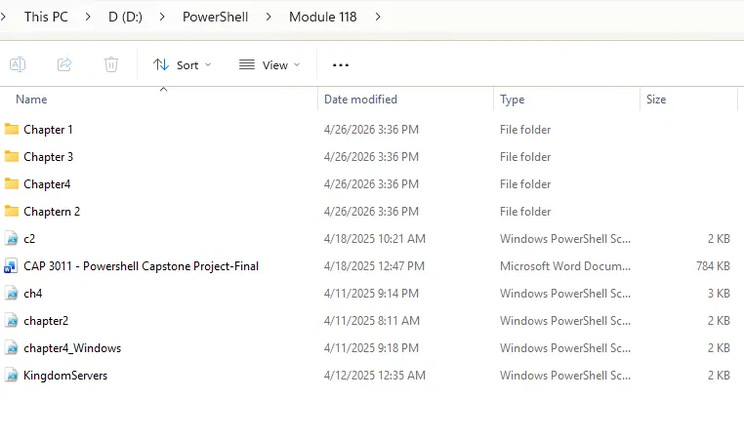
Figure 1. Local project folder structure before publishing. The public repository should use cleaned file names and no assignment submission material.

Chapter 1 - XML Artifact
The first module uses PowerShell to load an XML file, extract encrypted content, apply a simple character-shift decryption process, and write a short report of the result.
# scripts/chapter1-xml-scroll.ps1
$xmlPath = Join-Path $PSScriptRoot "..\data\AncientScroll.xml"
if (-not (Test-Path $xmlPath)) {
throw "AncientScroll.xml was not found at $xmlPath"
}

[xml]$xml = Get-Content -Path $xmlPath
$encryptedText = $xml.SelectSingleNode('//Content').InnerText
$decryptedText = ""

foreach ($char in $encryptedText.ToCharArray()) {
if ($char -eq ' ') { $decryptedText += ' '; continue }
if ($char -ge 'A' -and $char -le 'Z') {
$decryptedText += [char](((($char - 65) - 1) % 26) + 65)
} elseif ($char -ge 'a' -and $char -le 'z') {
$decryptedText += [char](((($char - 97) - 1) % 26) + 97)
} else {
$decryptedText += $char
}
}

$decryptedText

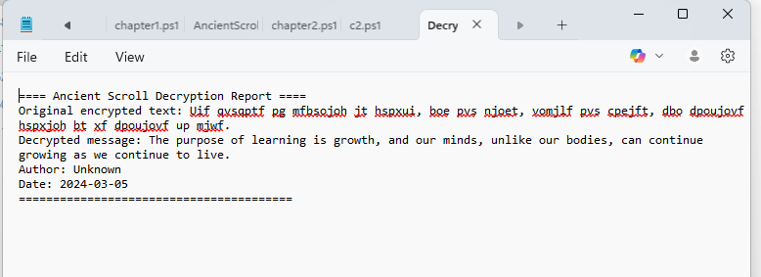
Figure 2. XML decryption report output generated from the PowerShell script.

Chapter 2 - Database Chronicles
The database module connects to a local SQL Server instance, creates a sample table, inserts records, and retrieves the results in PowerShell. For GitHub, connection strings should be generic and configurable.
# scripts/chapter2-sql-treasure.ps1
$connectionString = "Server=localhost;Database=master;Trusted_Connection=True;TrustServerCertificate=True;"
$connection = New-Object System.Data.SqlClient.SqlConnection($connectionString)

try {
$connection.Open()
$command = $connection.CreateCommand()
$command.CommandText = @"
IF OBJECT_ID('dbo.TreasureTable', 'U') IS NOT NULL DROP TABLE dbo.TreasureTable;
CREATE TABLE dbo.TreasureTable (
Id INT IDENTITY(1,1) PRIMARY KEY,
Name NVARCHAR(100) NOT NULL,
Value DECIMAL(10,2) NOT NULL
);
INSERT INTO dbo.TreasureTable (Name, Value) VALUES
('Golden Rubber Chicken', 499.99),
('Diamond-Encrusted Whoopee Cushion', 1250.00),
('Ancient Scroll of Dad Jokes', 42.42);
SELECT * FROM dbo.TreasureTable;
"@
$adapter = New-Object System.Data.SqlClient.SqlDataAdapter $command
$dataset = New-Object System.Data.DataSet
$adapter.Fill($dataset) | Out-Null
$dataset.Tables[0] | Format-Table -AutoSize
}
finally {
if ($connection.State -eq 'Open') { $connection.Close() }
}

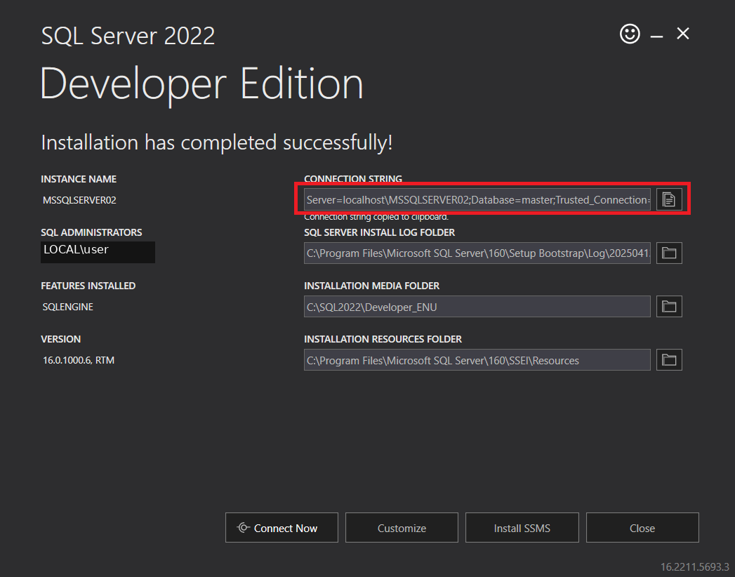
Figure 3. SQL Server Developer Edition installation confirmation with local account details redacted.
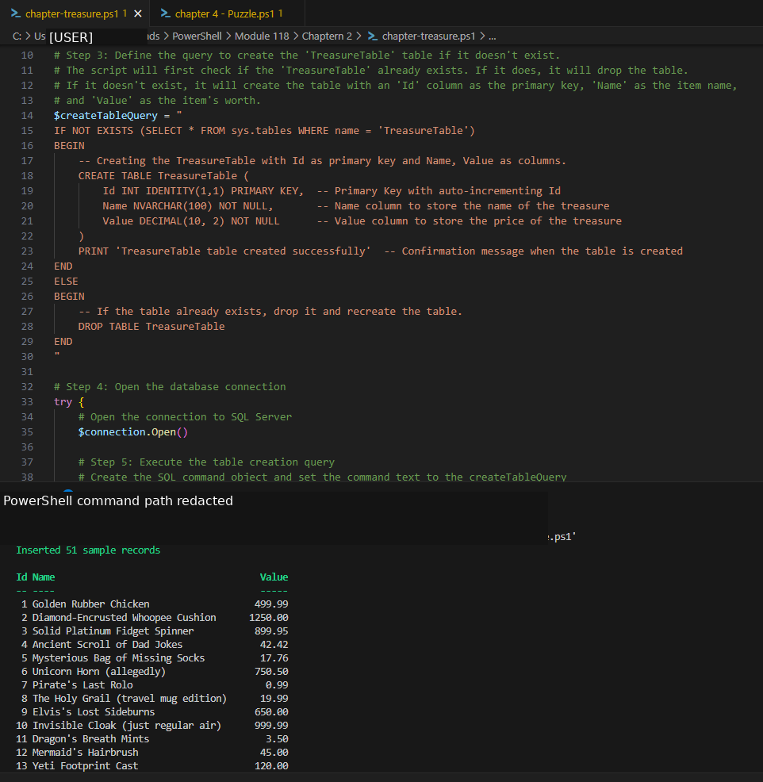
Figure 4. PowerShell execution showing SQL table creation, sample records, and formatted query output.

Chapter 3 - Web Wizardry
The web automation module uses Selenium with PowerShell to open a practice login page, enter demo credentials, verify the login result, and close the browser cleanly. For public GitHub code, do not hard-code real usernames or passwords.
# scripts/chapter3-web-automation.ps1
Import-Module Selenium

$driverDir = Join-Path $PSScriptRoot "..\drivers"
$driverExe = "chromedriver.exe"
$url = "https://the-internet.herokuapp.com/login"
$username = $env:DEMO_USERNAME
$password = $env:DEMO_PASSWORD

if (-not $username -or -not $password) {
throw "Set DEMO_USERNAME and DEMO_PASSWORD before running this script."
}

$options = New-Object OpenQA.Selenium.Chrome.ChromeOptions
$options.AddArgument("--disable-gpu")
$service = [OpenQA.Selenium.Chrome.ChromeDriverService]::CreateDefaultService($driverDir, $driverExe)

try {
$driver = New-Object OpenQA.Selenium.Chrome.ChromeDriver($service, $options)
$driver.Navigate().GoToUrl($url)
Start-Sleep -Seconds 2
$driver.FindElementById("username").SendKeys($username)
$driver.FindElementById("password").SendKeys($password)
$driver.FindElementByClassName("radius").Click()
Start-Sleep -Seconds 2
Write-Host "Login result:" $driver.FindElementById("flash").Text
}
finally {
if ($driver) { $driver.Quit() }
}

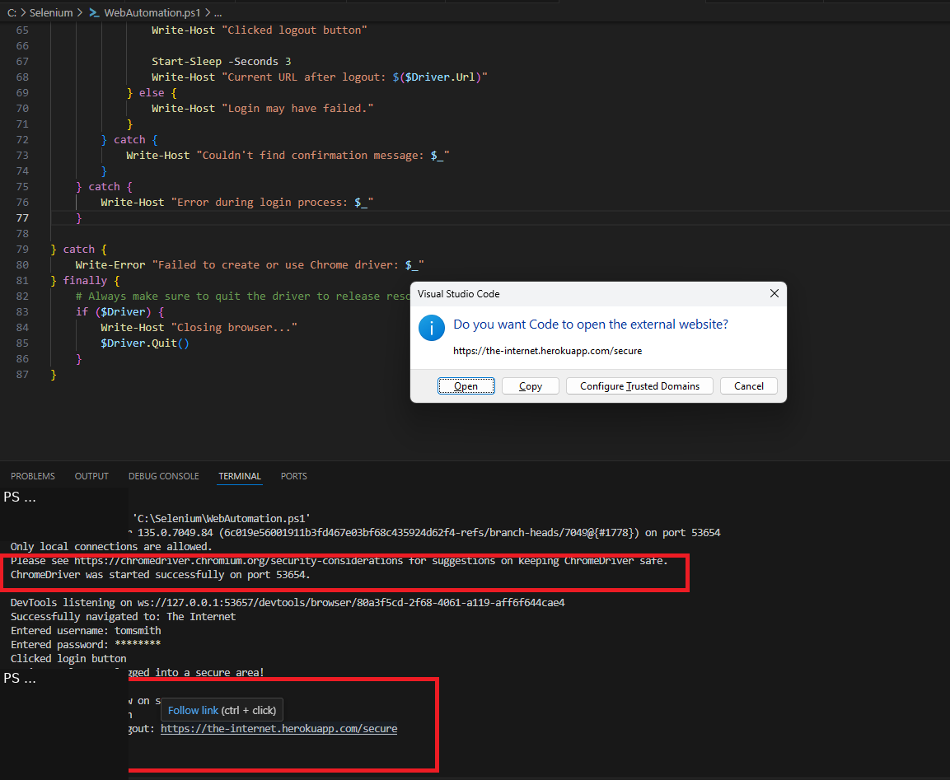
Figure 5. Selenium automation run in Visual Studio Code with local user path redacted.

Chapter 4 - DSC Chronicles
The DSC module defines a desired server state. In a production repository, generated MOF files should usually be excluded from GitHub because they can contain machine-specific information.
# scripts/chapter4-dsc-config.ps1
Configuration KingdomServers {
param(
[Parameter(Mandatory=$true)]
[string]$NodeName
)

Import-DscResource -ModuleName PSDesiredStateConfiguration

Node $NodeName {
WindowsFeature WebServer {
Name = "Web-Server"
Ensure = "Present"
}

File KingdomWebDirectory {
DestinationPath = "C:\KingdomWeb"
Type = "Directory"
Ensure = "Present"
}
}
}

$configPath = Join-Path $PSScriptRoot "..\output\DSCConfigs"
KingdomServers -NodeName "localhost" -OutputPath $configPath

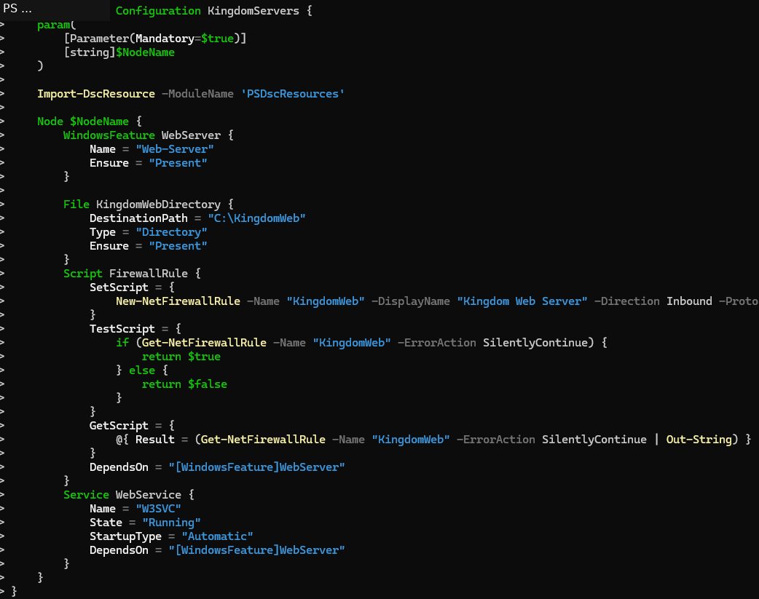
Figure 6. DSC configuration script example with the local username redacted from the terminal prompt.

